REPORT OF ECOMMERCE SHOPPING APPLICATION

FROM

SYED ASIMUDDIN

ROLL NO:19UK1A0517

VAAGDEVI ENGINEERING COLLEGE

**project URL:**

<https://iacademy.oracle.com/ords/f?p=319:LOGIN_DESKTOP:13610835576753:::::>

**login details:**

Username: IN_A408_SQL_S12

Password: Asim9866566054@

alternate:

username: smart123

password: 123456789

(if the above does not work use this credentials)

ABSTRACT

Now a days the life style of the people is different. People feel uncomfortable and time consuming for going crowded markets. So, E-Shopping is a boon as it saves lot of time. Online shopping is a process whereby consumers directly buy goods, services etc. from a seller without an intermediary service over the Internet. Shoppers can visit web stores from the comfort of their house and shop as by sitting in front of the computer. Online stores are usually available 24 hours a day and many consumers have internet access both at work and at home. So it is very convenient for them to shop Online. One of the most enticing factors about online shopping, particularly during holiday season is, it alleviates the need to wait in long lines or search from a store for a particular item. Variety of goods are available in online. So the researcher want to know the preference of the consumers. So fifty respondents were met and data were collected regarding their preference towards shopping online.

**CONTENTS**

**S.No TOPIC**

**1.INTRODUCTION**

**2.THEORITICAL ANALYSIS**

**3. FLOW CHART**

**4. RESULT**

**5. ADVANTAGES & DISADVANTAGES**

**6. APPLICATIONS**

**7. CONCLUSION**

**8. FUTURE SCOPE**

**9. APPENDIX**

**1.INTRODUCTION**

Online shopping is becoming increasingly popular for variety of reasons. There are certainly outside factors such as increasing gas prices, difficulty in getting to traditional stores and hassles often associated with shopping malls and other traditional stores to contribute to the increased interest in online shopping.

Consumers can get full information about the product with its reviews being passed by the existing users. If one wants to buy a product he/she is no longer limited to asking the friends and families because there are many products reviews on the web which gives opinions of the existing users of the product.

Online shopping sites contain wide variety of goods both high quality and mild quality keeping in mind the level of people.

**2. THEORITICAL ANALYSIS**

**Architecture:**

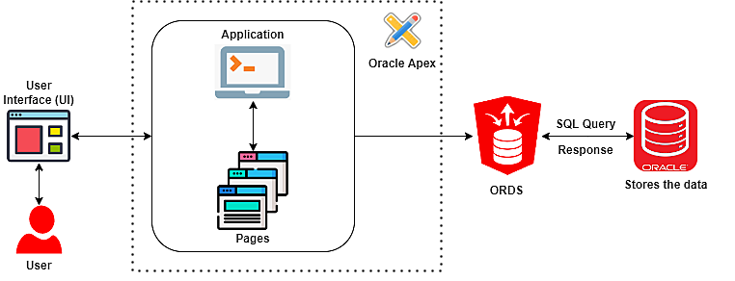

Shopping Cart application that allows managing products, customers, and stores. The application will have two application roles:

Administrators:

* To manage the products, customers and stores
* To access a dashboard to identify the top products

Customers:

* To review, add, delete, or edit the number of products in the shopping cart
* To submit orders

**3. FLOWCHART**

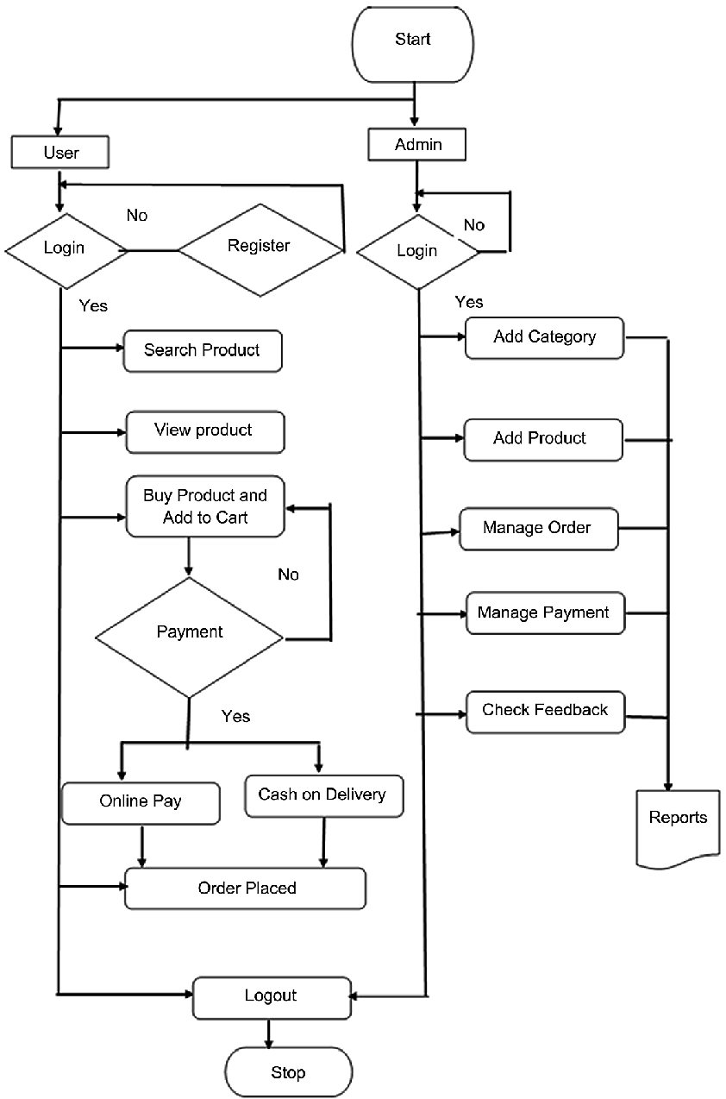

**4.RESULT**

**steps to follow for results:**

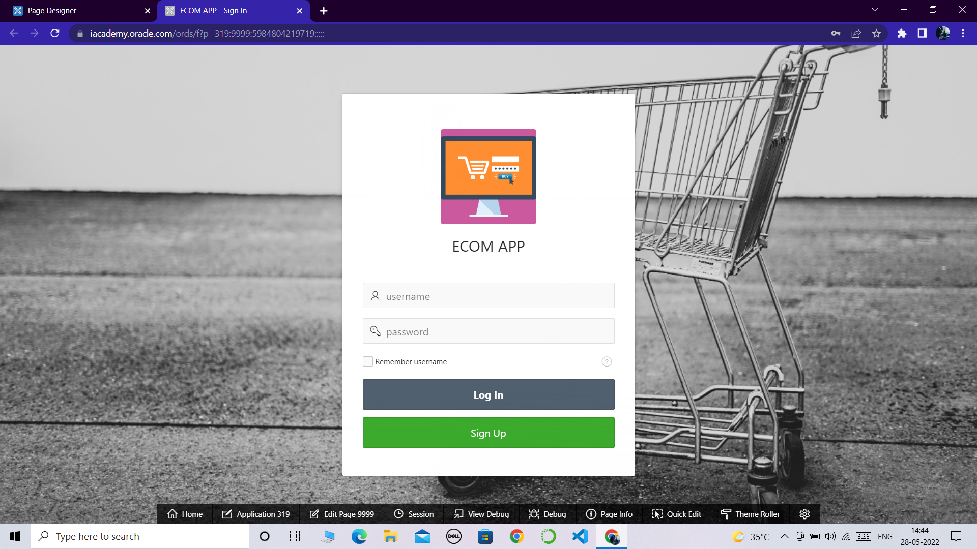

**STEP-1:** *The user will enter into the login page immediately after opening the ecom web app.*

**STEP-2:***click on SIGN UP button to register if your a new user.*

*if you are an existing user then use your username and*

*password to LOGIN into the ecom app*

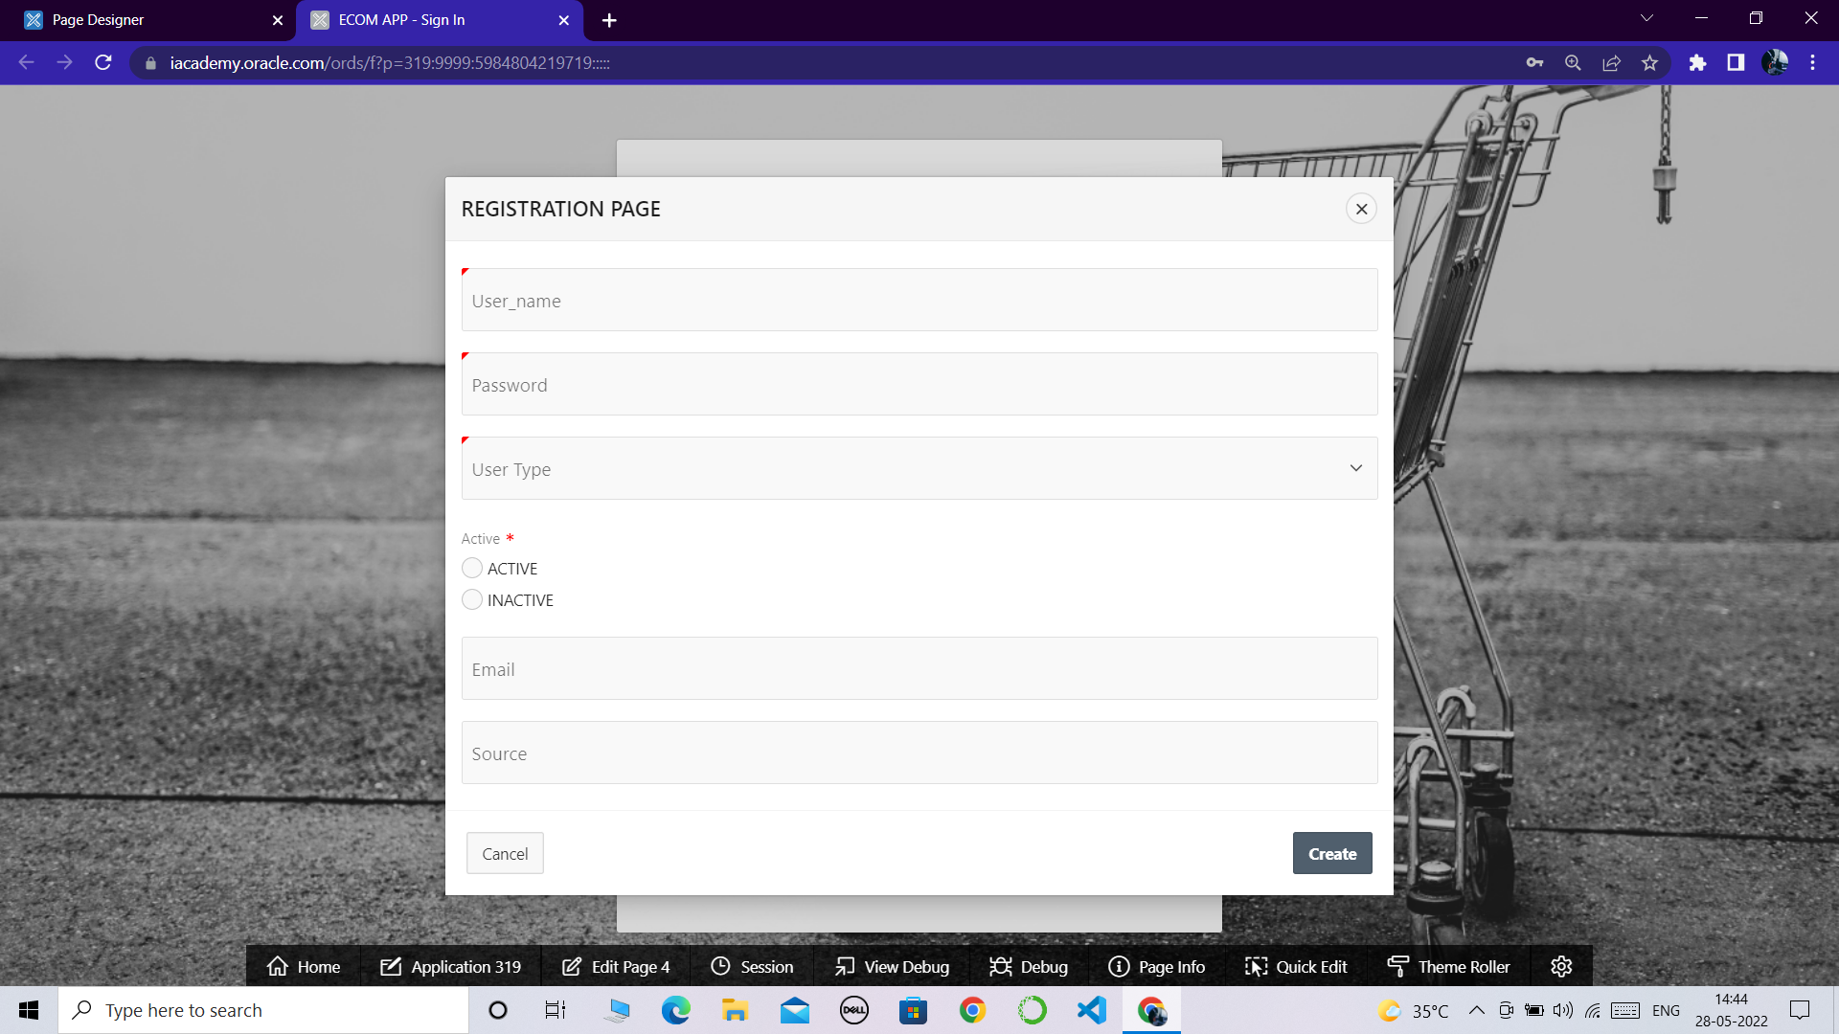

**STEP-3:** *when you click on the SIGN UP button you will be redirected to registration page.*

**STEP-4:** *Enter you credentials in the registration page such as*

*->username*

*->password*

*->user type*

*->active status*

*->email*

*->source*

**STEP-5:***then click on create*

*your registration will be succesfull*

*use the credentials to login into the ECOM App*

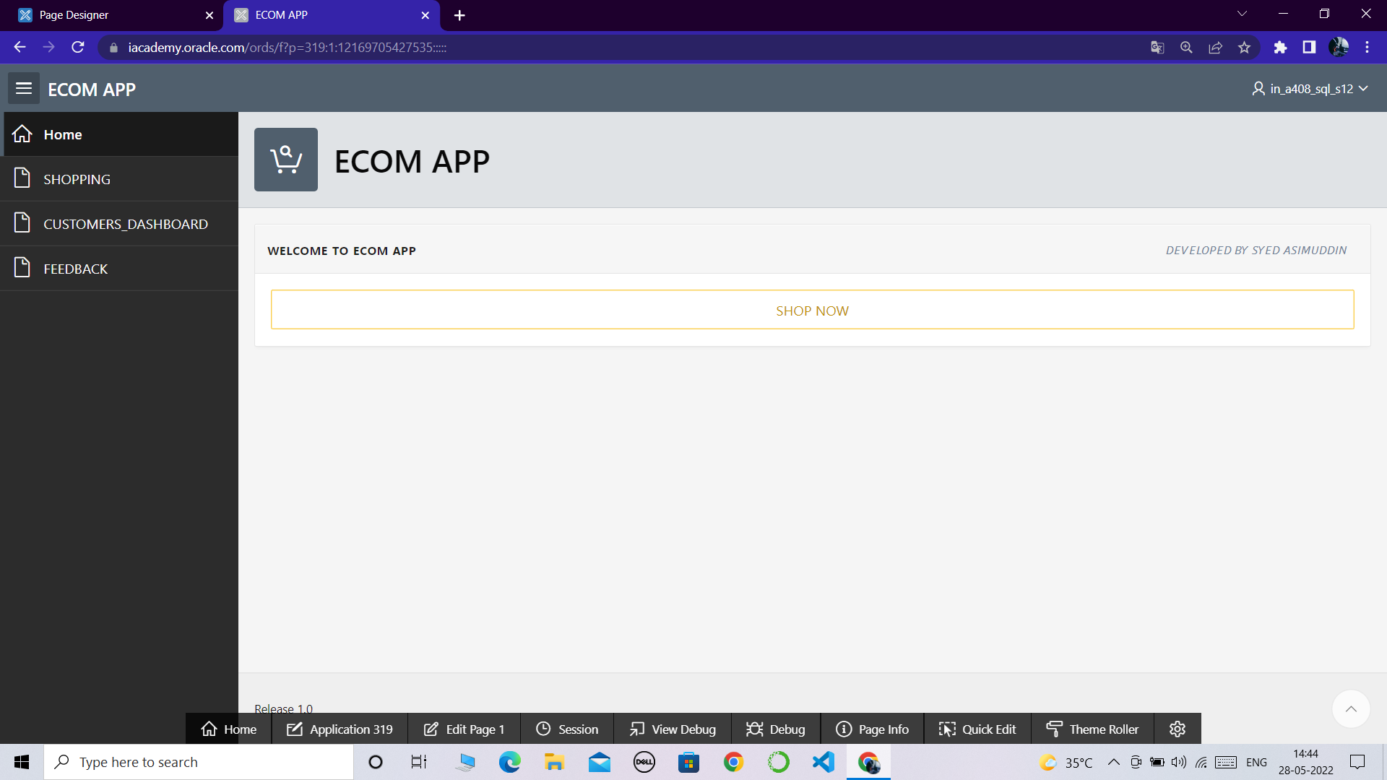

**STEP-6:***after you logged in into the app the above interface will be appeared with home page*

*welcome to ecom app*

**STEP-7:***now click on shop now button then you will be redirect to the shopping page*

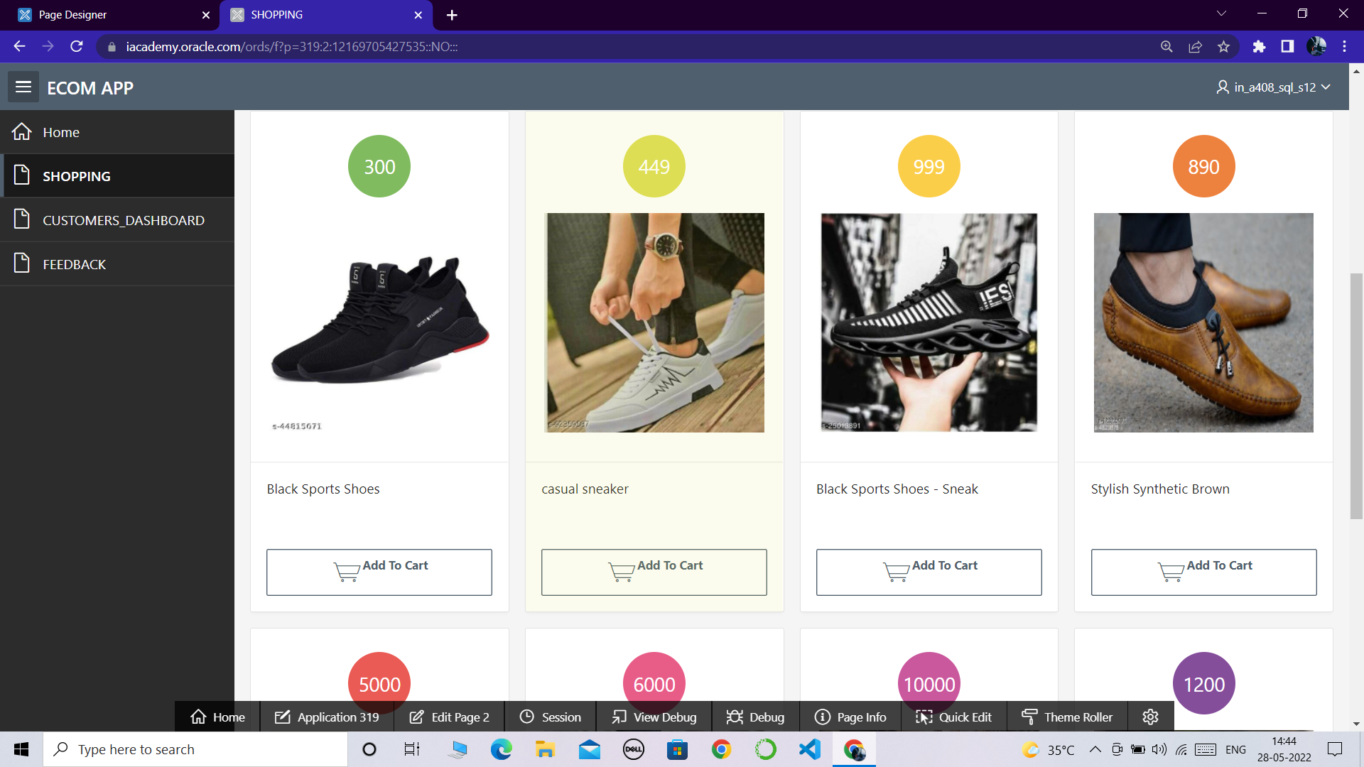

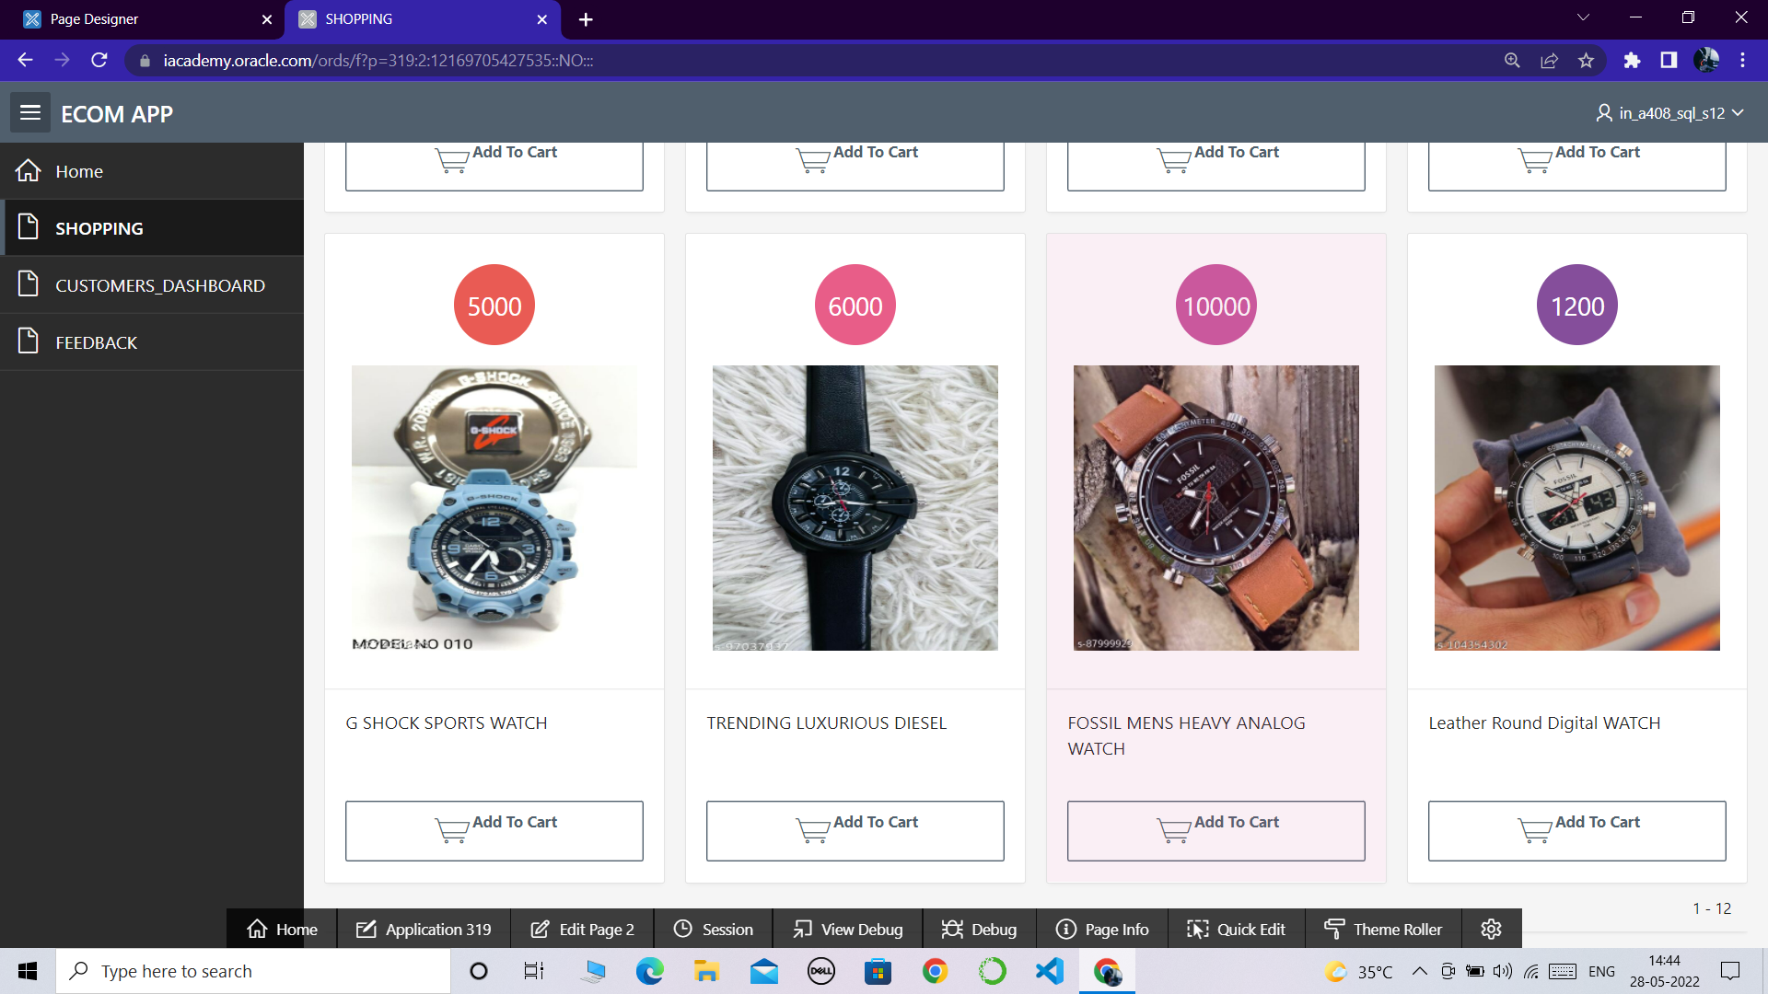

**STEP-8:** *wide range of clothing and style products will be visible in the shopping page*

**STEP-9:***click on add to cart button on any product you like and wanted to order it*

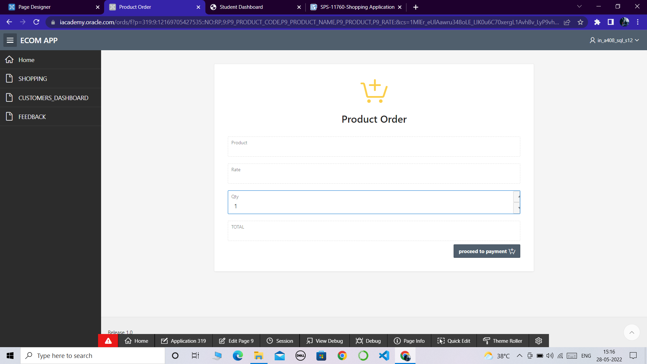

**STEP-9:** *select**the**quantity you want and then click on the proceed to payment button to checkout your order*

**STEP-10:** *enter all your adreess details and also select the payment method in the form then click on place order to place and confirm your order*

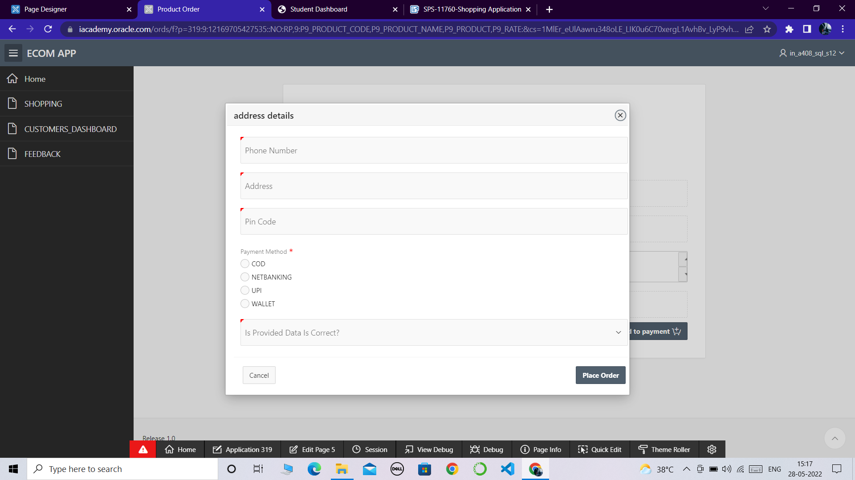

**STEP-11:** *when you click on the place order your order will be confirmed and placed*

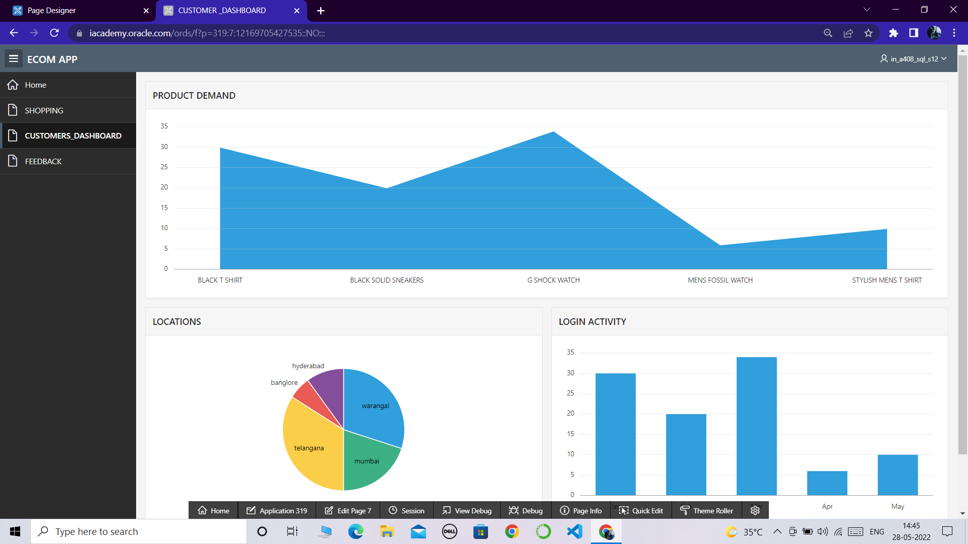

**STEP-12:** *click on customers dashboard to check the customer stats*

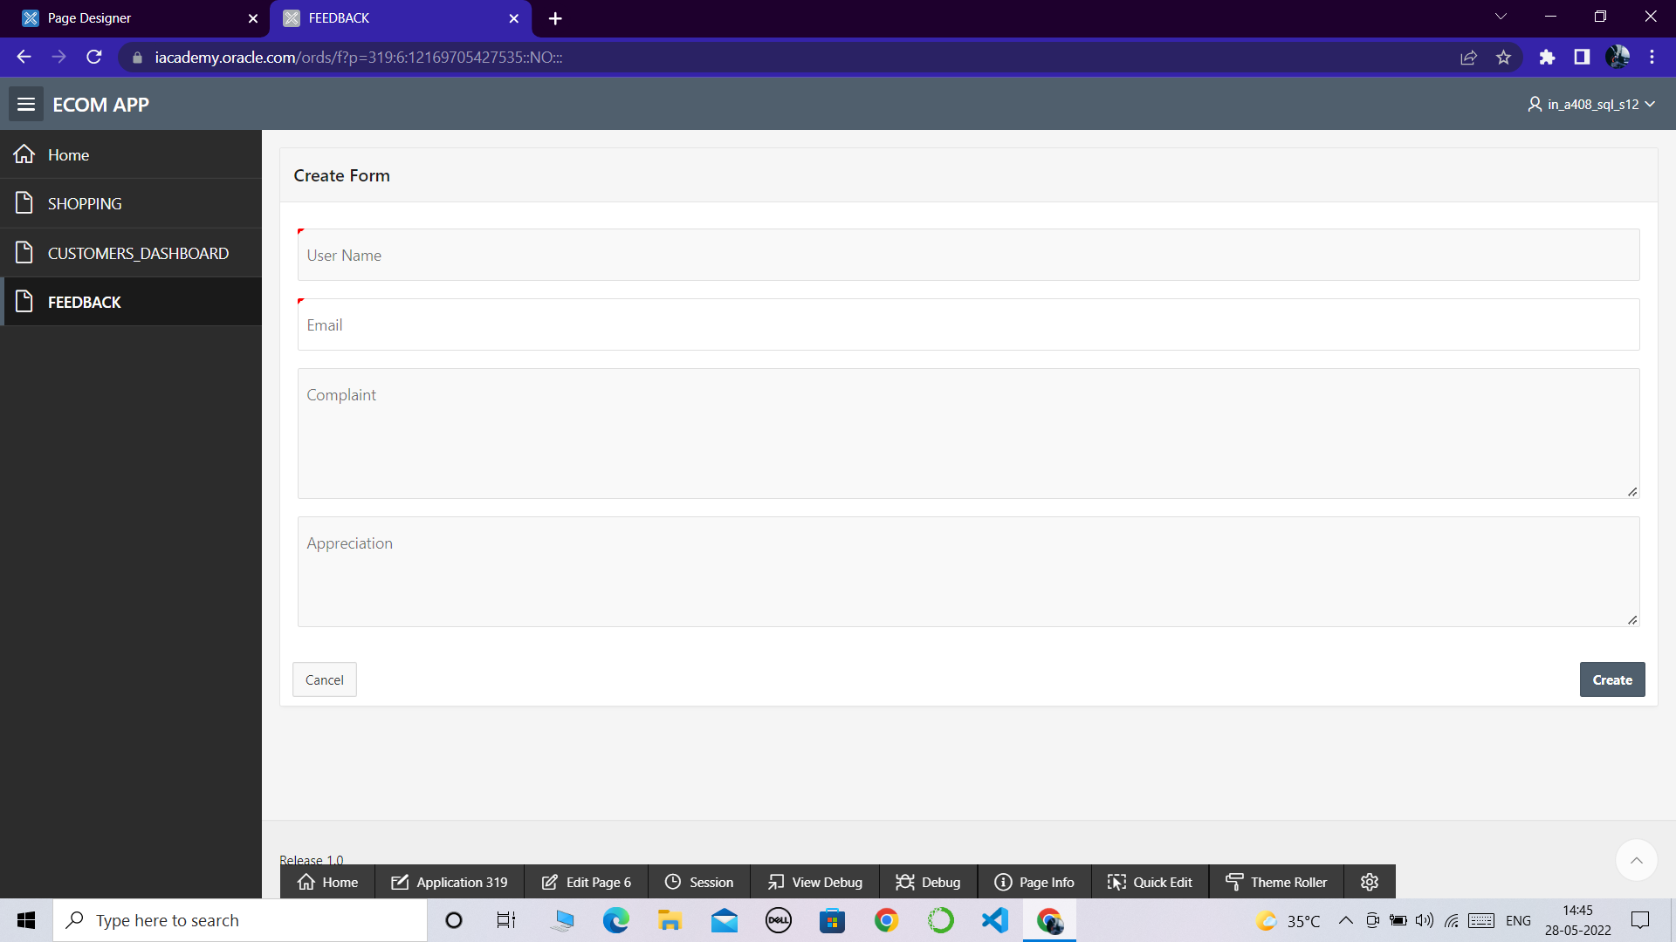

**STEP-13:***click on feedback for any kind of complaints or appreciations*

**5. ADVANTAGES AND DISADVANTAGES**

|  |  |
| --- | --- |
| **Advantages of Shopping application** | **Disadvantages of Shopping application** |
| Better Prices | Shipping Problems and Delays |
| More Variety | Risk of Fraud |
| Easy to Send Gifts | Less Contact With Your Community |
| More Control  easy interface  fast access  user defined timings | Spending Too Much Time Online  data loss  no privacy |

**6. APPLICATIONS:**

The purpose of shopping cart software is to support the work of online merchants with larger customer databases, and enable at least a simplified self-service method. On an eCommerce website with a reliable shopping cart service, prospective buyers have the possibility to preselect, reserve, and store items they’d like to own. The cart itself is often the leading element that inspires trust in the shopping process, and lets them know they’re dealing with a professional provider. On the owner’s side of the axis, meanwhile, this leads to accelerated checkout and out-of-the-box possibilities to cross-sell related products, and please customers with ‘just-what-I-wanted’ offers.

**7.CONCLUSION:**

The researcher made a thorough analysis over the Study of customer preference towards online shopping with reference to Nagercoil town. It is of the opinion that , though there are a number of products available in the market , large number of respondents mostly prefer to purchase Books through online shopping. Because variety of Books are available while searching online web stores.

**8. FUTURE SCOPE:**

Greater personalization of ads, retargeting, and automated marketing to ensure maximum conversion of visitors, abandoned cart shoppers etc.

The future of online shopping depends on savvy professionals who can create a personalized, engaging virtual shopping experience for consumers. Those entering a career in business administration must adopt the latest digital technologies and tools — such as data analytics, machine learning, and mobile trends — to meet the demands of today’s online shopper.

**9. APPENDIX**

**a.source code of products table :**

CREATE TABLE "PRODUCTS_DTL"

( "ID" NUMBER,

"PRODUCT_CODE" VARCHAR2(30),

"PRODUCT_NMAE" VARCHAR2(30),

"IMAGE" BLOB,

"PRICE" NUMBER(12,2)

)

/

**b.source code of order products :**

CREATE TABLE "ORDER_PRODUCT1"

( "ID" NUMBER,

"PRODUCT_CODE" VARCHAR2(300),

"PRODUCT" VARCHAR2(300),

"RATE" NUMBER,

"QTY" NUMBER,

"USER_NAME" VARCHAR2(20)

)

**c.source code of inline css:**

select "ID",

"PRODUCT_CODE" CARD_SUBTEXT,

"PRODUCT_NMAE" CARD_TEXT,

sys.dbms_lob.getlength("IMAGE") "CARD_TITLE",

"PRICE" CARD_INITIALS

from "PRODUCTS_DTL"